From Engagement to Accountability: A Capital-Driven System for Sustained IELTS Preparation

Context
IELTS preparation spans weeks to months, yet meaningful engagement on preparation platforms occurs mostly in the final days before the exam. Early preparation feels invisible, progress is unclear, and delay carries no immediate consequence. This disconnect weakens sustained effort despite strong long-term intent to study abroad.

Core Failure in Existing Products
Current solutions measure activity, not readiness. They depend on reminders, streaks, or content consumption metrics that drive short-term interaction but fail across long preparation cycles. A major behavioural gap remains unaddressed: substantial preparation happens outside the platform (e.g., YouTube), leaving real effort uncaptured and unvalidated.

User Reality
Target users (18–26, students or early professionals planning global education) show:
- High aspiration with fragmented daily schedules
- Motivation tied to visible short-term progress
- Ongoing off-platform preparation
Key insight:
Motivation is present. Accountable, cumulative recognition of effort is missing.
Engagement collapses when preparation has no measurable capital, no visible trajectory, and no consequence for delay.

Conceptual Output Flow (Problem State) 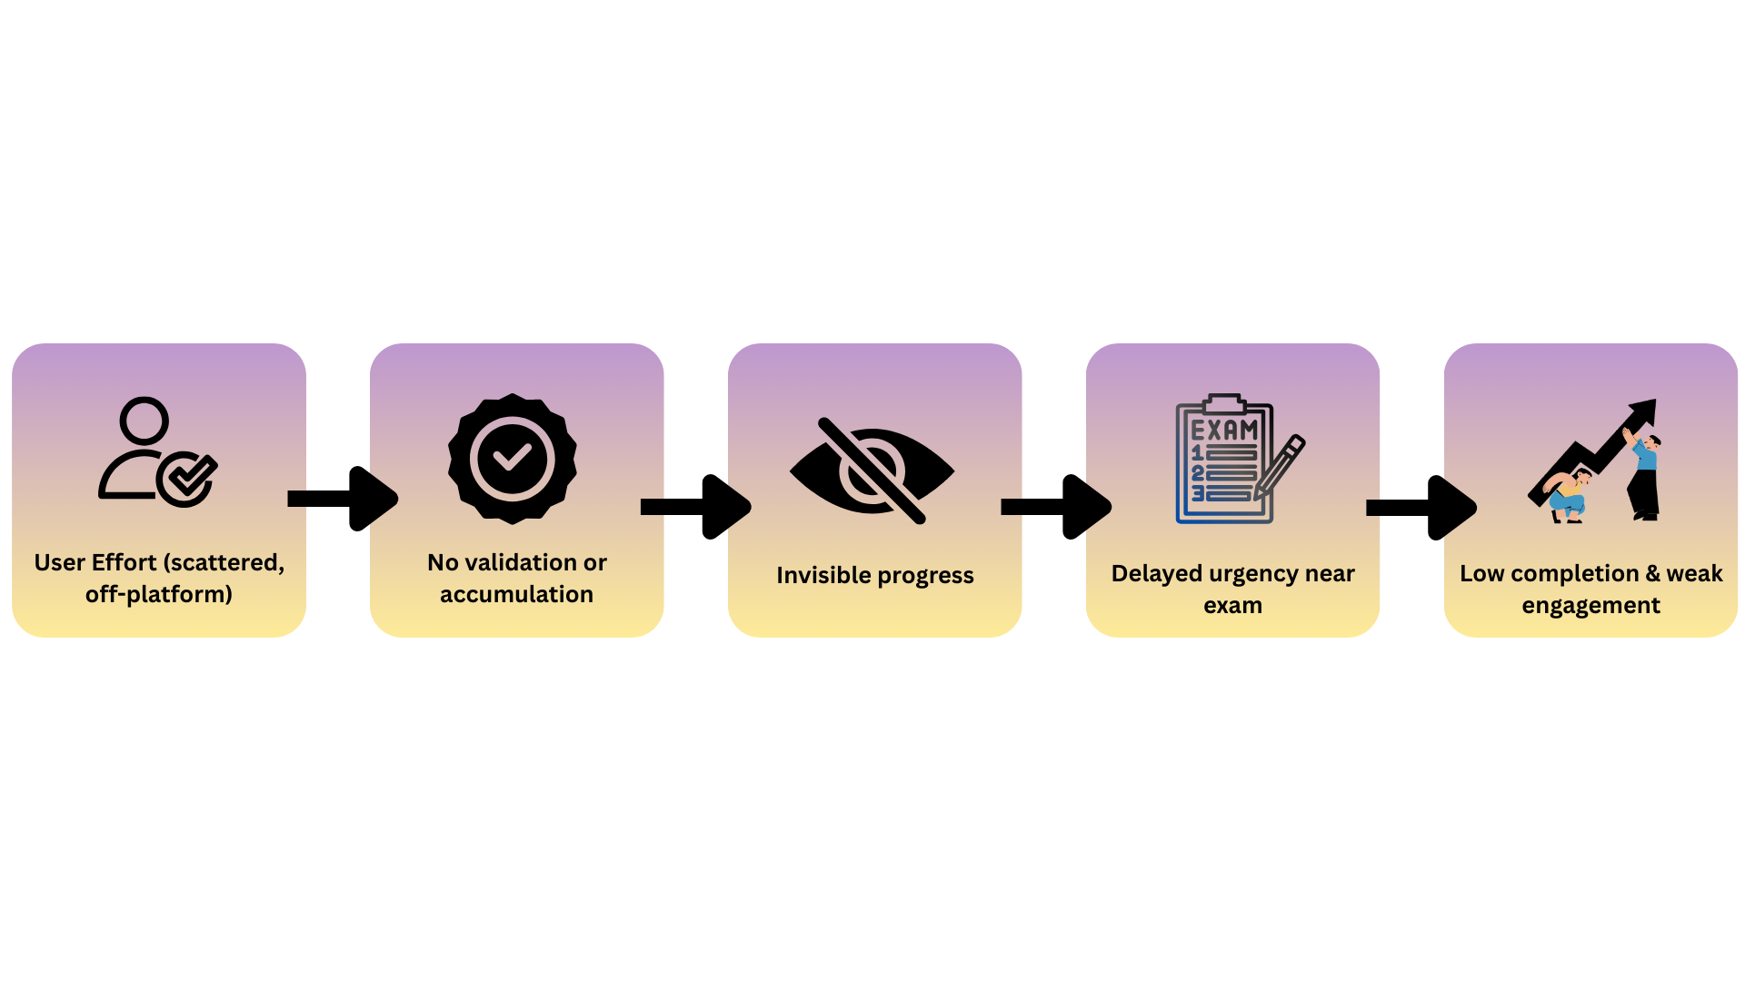
System Gap Architecture (Current Reality)
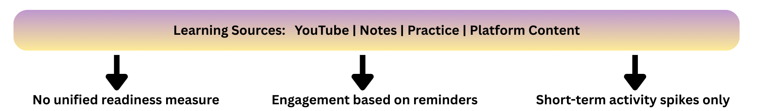

Core Reframe
Traditional engagement strategies attempt to increase user activity through reminders, streaks, or content volume. However, activity alone does not guarantee readiness, consistency, or completion across long preparation cycles.
This solution reframes the objective:
From increasing engagement to creating accountable preparation that compounds over time. The platform therefore shifts from a content destination to a readiness infrastructure.

System Primitive — Preparation Capital (PC)
Preparation Capital (PC) is a deterministic measure of verified exam readiness that accumulates through meaningful learning activity.
PC is governed by five core properties:
- Validation-driven: Only verified learning contributes to readiness.
- Consistency-weighted: Regular effort compounds more than sporadic intensity.
- Decay-aware: Inactivity gradually erodes accumulated readiness.
- Non-resetting: Progress is never erased, preserving user trust.
- Forecastable: Current PC enables early projection of success or failure before the exam date.
This converts preparation from a time-based activity into a capital-based progression system.

External Effort Capture
A significant portion of IELTS preparation occurs outside the platform, particularly through freely available video content and informal study resources. Ignoring this reality fragments readiness measurement and weakens engagement continuity.
The proposed system treats external learning as raw effort that must be validated before contributing to Preparation Capital. Without validation, effort does not accumulate toward readiness. This positions the platform as the single ledger of record for preparation—regardless of where learning originates.
Traditional model: Content → Activity → Short-term engagement
Proposed model: Validated effort → Preparation Capital → Readiness trajectory → Completion

From Motivation to Consequence
Most preparation products attempt to sustain engagement through reminders, streaks, or emotional nudging. These mechanisms generate short bursts of activity but fail to support long-cycle consistency required for exam readiness.
This system replaces motivational engagement with structural consequence.
Users do not return to maintain streaks. They return to protect earned leverage. Retention therefore emerges from what is at risk, not from what is encouraged.

Commitment Bands — Replacing Streaks with Contracts
Traditional streak systems reward continuous presence rather than meaningful preparation. They are fragile, easily broken, and often lead to disengagement after interruption.
The proposed model introduces Commitment Bands—contract-like preparation states defined by:
- Minimum validated activity cadence
- Eligibility for escrowed benefits
- Detection of inactivity violations without emotional pressure
Validated effort → Preparation Capital → Commitment Band → Escrow eligibility
Unlike streaks, Commitment Bands emphasize preparedness continuity, not daily attendance.

Escrowed Benefits — The Core Retention Mechanism
As users accumulate Preparation Capital, they unlock time-bound real-world leverage, such as:
- Fee reductions
- Priority expert access
- Physical preparation resources
These benefits are not immediately consumed. Instead, they are placed in escrow, introducing visible ownership and potential loss.

Escrow Lifecycle
Unlock → Active ownership → Visible decay during inactivity → Grace recovery → Permanent expiry
Behavioural effect:
- Progress is not deleted
- Effort is not invalidated
- Only future leverage becomes vulnerable
This preserves user trust while maintaining meaningful pressure to return.

Inactivity Without Punishment
A critical design principle is avoiding destructive resets.
- Preparation Capital never returns to zero
- Historical effort remains intact and respected
- Only unprotected leverage is lost through inactivity
This prevents rage-quit behaviour while sustaining accountability.

Why Consequence Sustains Engagement
Streak systems: Presence → Break → Disengagement

Escrow system: Effort → Ownership → Risk → Return to protect value

Early Visibility Instead of Late Urgency
Traditional preparation behaviour is defined by delayed urgency; users increase effort only when the exam date approaches and remaining time becomes visibly scarce. This system reverses that dynamic by making future readiness visible during the earliest weeks of preparation. The goal is not to push users harder near the exam, but to reveal trajectory risk early enough for small corrections to matter.

First Four Weeks of Preparation

Week 1 — Rapid Signal Formation
Initial validated activity converts into Preparation Capital, producing visible early progress.
Users quickly perceive that effort is accumulative rather than disposable.

Weeks 2–3 — Consistency Becomes Structural
Sustained activity determines:
- Entry into Commitment Bands
- Eligibility for escrowed leverage
- Protection against readiness decay
At this stage, engagement shifts from trying to study toward maintaining owned progress.

Week 4 — Trajectory Divergence Appears
By the fourth week, two clear readiness paths emerge:
Consistent effort → Rising Preparation Capital → Stable escrow → Projected readiness

Inconsistent effort → Capital decay → Escrow risk → Projected shortfall
This divergence occurs far earlier than traditional last-minute urgency, enabling meaningful behavioural correction.

Momentum Forecast — Making the Future Observable
The system introduces a deterministic forecast answering a single question: “At the current pace, will the user reach readiness before the exam?”
Key properties of the forecast:
- Based on validated historical effort, not intention
- Produces transparent success or failure trajectories
- Avoids optimistic bias or motivational language
- Enables early corrective action through small consistency gains

Measurable Impact on Core Product Metrics
The proposed system is designed to influence long-cycle engagement metrics, not short-term interaction signals. Sessions per user (first four weeks) increase driven by:
- External effort validation pull
- Escrow recovery windows that require timely return
- Commitment Bands enforcing structural consistency
- Irreversible escrow expiry, creating meaningful consequence for delay
Motivation, momentum, and sustained preparation
Strengthened by:
- Continuous visibility of Preparation Capital growth
- Deterministic trajectory forecasting before the exam date
Retention quality (not vanity retention) Shifted from a Reminder-driven logins to Value-protection–driven return behaviour rooted in owned leverage

Prototype-Level Execution Validation
A working Streamlit behavioral simulator demonstrates the feasibility of the system prior to production development. The system demonstrates:
- Preparation Capital accrual and decay logic
- External effort validation and conversion
- Commitment Band transitions
- Full escrow lifecycle (unlock → decay → recovery → expiry)
- Deterministic success/failure forecasting
Implementation Link: https://leap-finance-demo.streamlit.app/
GitHub Documentation: https://github.com/Zian-Surani/Leap-Finance

Strategic Implication for Leap
By shifting engagement from motivation to accountability,
Leap can sustain preparation continuity across extended timelines while strengthening:
- User trust in measurable readiness
- Alignment between daily effort and final outcome
- Long-term completion and conversion metrics
The platform evolves from a content provider into a system that safeguards preparation progress.

Closing Statement
This solution replaces motivational engagement with economic and behavioural accountability.
By transforming preparation into measurable capital that compounds, unlocks real leverage, and decays with inactivity, Leap gains a structurally stronger path to sustained engagement, higher completion, and outcome certainty across long-cycle exam preparation.

